**Experiment No 1** **Date:** 14-09-2023

**Name:** Abhay Mathur **SAPID:** 60017210016 **Batch:** A1

**Title: Plot of Discrete Time Signals**

**Aim:** ToPlot the Discrete Time Signals

Plot the following discrete time signals using folding and shifting property:

* Delta Function
* Unit Step Function
* Ramp Function
* 2(n) u(n)
* 2(n) u(n+1)
* 2(n) u(n-1)
* 2(n) u(-n+1)
* 2(n) u(-n-1)

**Learning Objectives: At the end of this experiment, students will be able to:**

* To Plot different signals
* To learn speech processing

**Apparatus**: Python - Jupyter

**Theory:** A signal is defined as any physical quantity that varies with time, space, or any other independent variable or variables. Mathematically, we describe a signal as a function of one or more independent variables. For example, the functions

S1 (t) = 5t

S2 (t) = 20t²

describe two signals, one that varies linearly with the independent variable (time) and a second that varies quadratically with t. Signals can be further classified into four different categories depending on the characteristics of the time (independent) variable and the values they take.

Continuous-time signals or analog signals are defined for every value of time and they take on values in the continuous interval (a, b) w here a can be -∞ and b can be ∞. Mathematically, these signals can be described by functions of a continuous variable. The speech waveforms are shown in figure below

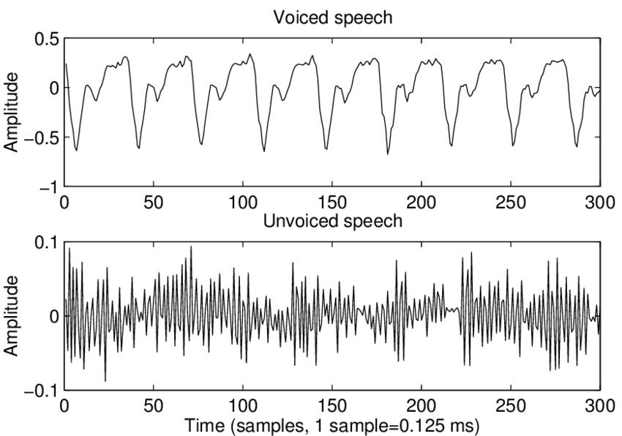

Discrete-time signals are defined only at certain specific values of time. These time instants need not be equidistant, but in practice they a usually taken at equally spaced intervals for computational convenient and mathematical tractability. The signal x (n) = 0.8n n = 0, ±1,±2 ... provides an example of a discrete -time signal. If we use the index n of the discrete-time instants as the independent variable, the sign value becomes a function of an integer variable (i.e., a square: numbers). Thus a mathematically by a discrete-time signal can be represented sequence of real or complex numbers. T emphasize the discrete-time nature of a signal, we shall denote such signal as x (n) instead of x (t). If the time instants are equally space (i.e., t = nT), the notation is also used. For the following examples of

* Step function
* Impulse function
* Exponential function
* Ramp function
* Sine function
* Cosine function

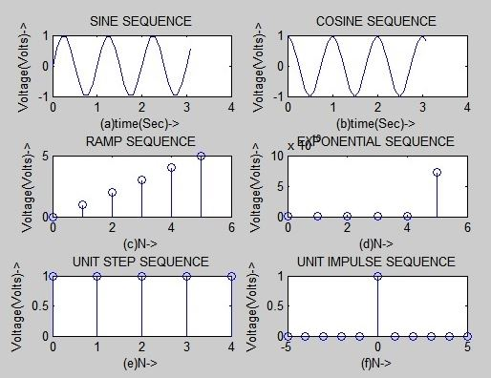

**Code:**

import matplotlib.pyplot as plt

#Delta Function

def delta(d):

plt.figure(figsize=(10, 5))

for n in range(-10, 10):

if d(n) == 0:

delta = 1

else:

delta = 0

plt.stem(n, delta)

plt.title('Delta Function')

plt.xlabel('n')

plt.ylabel('delta[n]')

plt.xticks(range(-10, 10))

# Unit Step Function

def unit(d):

plt.figure(figsize=(10, 5))

for n in range(-10, 10):

if d(n) < 0:

u = 0

else:

u = 1

plt.stem(n, u)

plt.title('Unit Step Function')

plt.xlabel('n')

plt.ylabel('u[n]')

plt.xticks(range(-10, 10))

# Ramp Function

def ramp(d):

plt.figure(figsize=(10, 5))

for n in range(-10, 10):

if d(n) < 0:

p = 0

else:

p = n

plt.stem(n, p)

plt.title('Ramp Function')

plt.xlabel('n')

plt.ylabel('p[n]')

plt.xticks(range(-10, 10))

# (2^n)*u[n]

def exp(d):

plt.figure(figsize=(10, 5))

for n in range(-10, 10):

if d(n) < 0:

exp = 0

else:

exp = 2**n

plt.stem(n, exp)

plt.title('Exponential Function')

plt.xlabel('n')

plt.ylabel('2^n u[n]')

plt.xticks(range(-10, 10))

#Delta Function Graph

delta(lambda n: n)

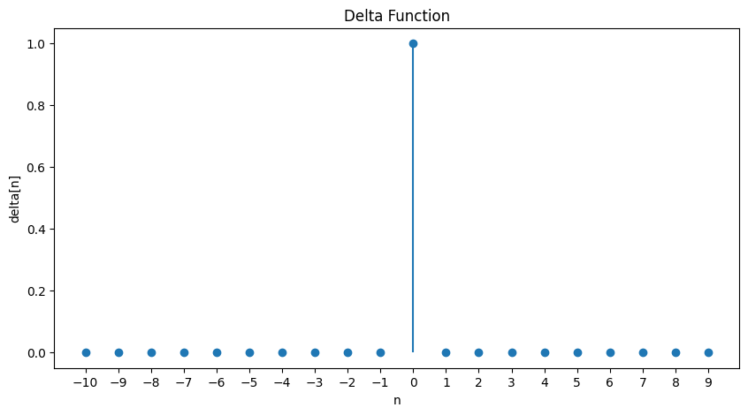

#Unit Step Function Graph

unit(lambda n: n)

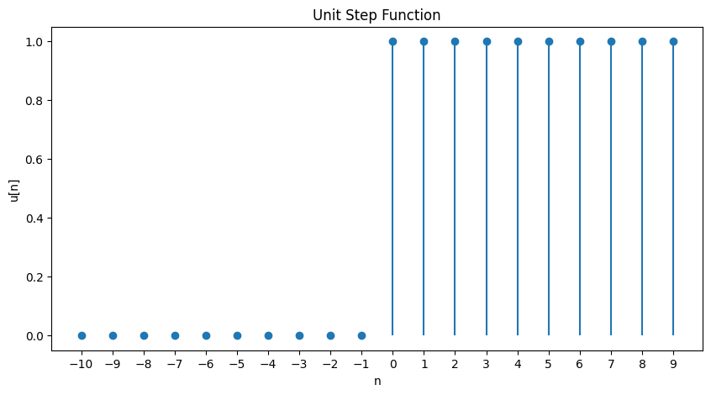

#Ramp Function Graph

ramp(lambda n: n)

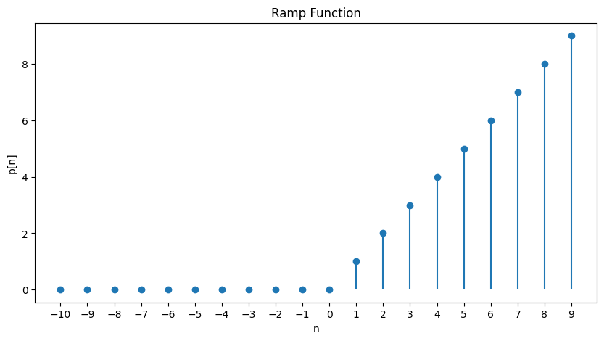

# (2^n)*u[n] Function Graph

exp(lambda n: n)

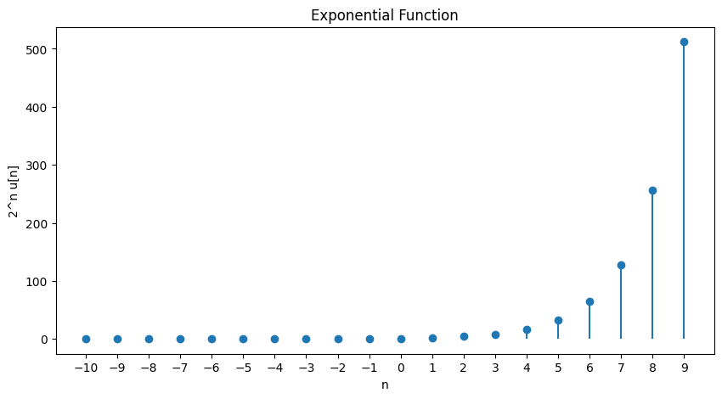

# (2^n)*u[n+1] Function Graph

exp(lambda n: n+1)



# (2^n)*u[n-1] Function Graph

exp(lambda n: n-1)



# (2^n)*u[-n+1] Function Graph

exp(lambda n: -n+1)

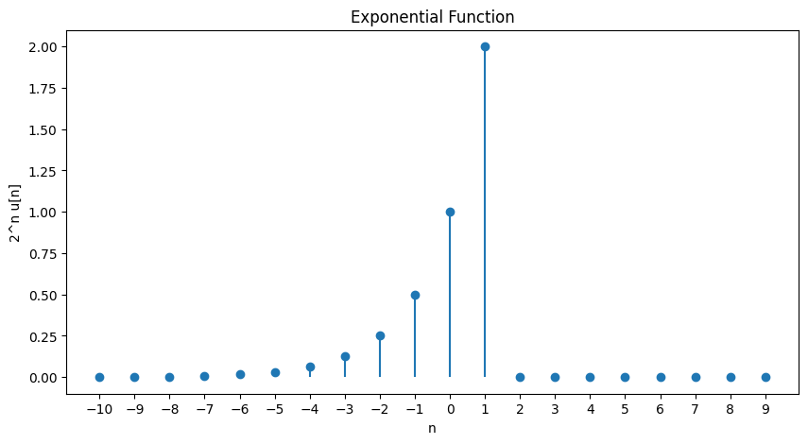

# (2^n)*u[-n-1] Function Graph

exp(lambda n: -n-1)

